Day 35 - 11th Sept 2025

DAX (DynamoDB Accelerator)

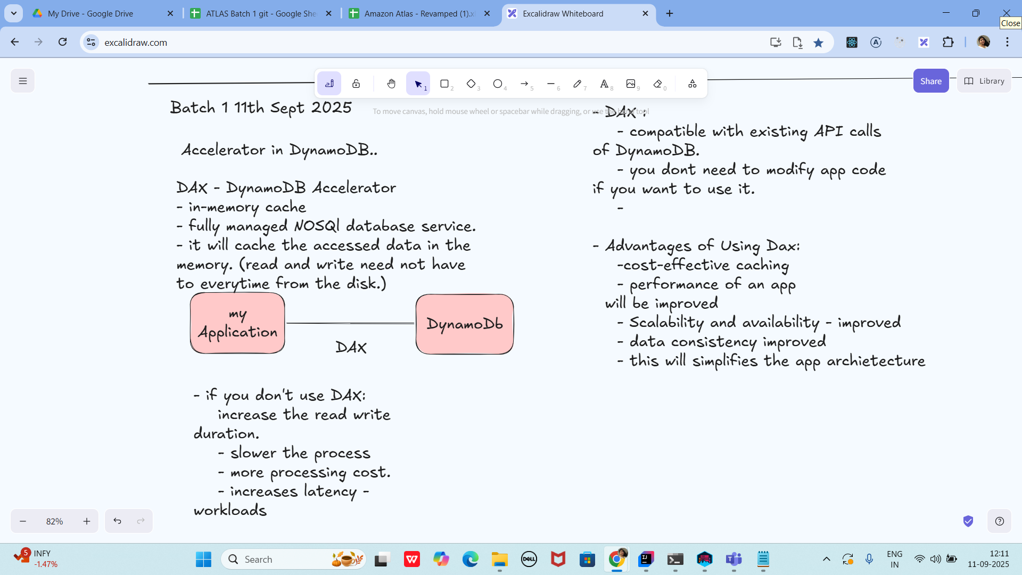

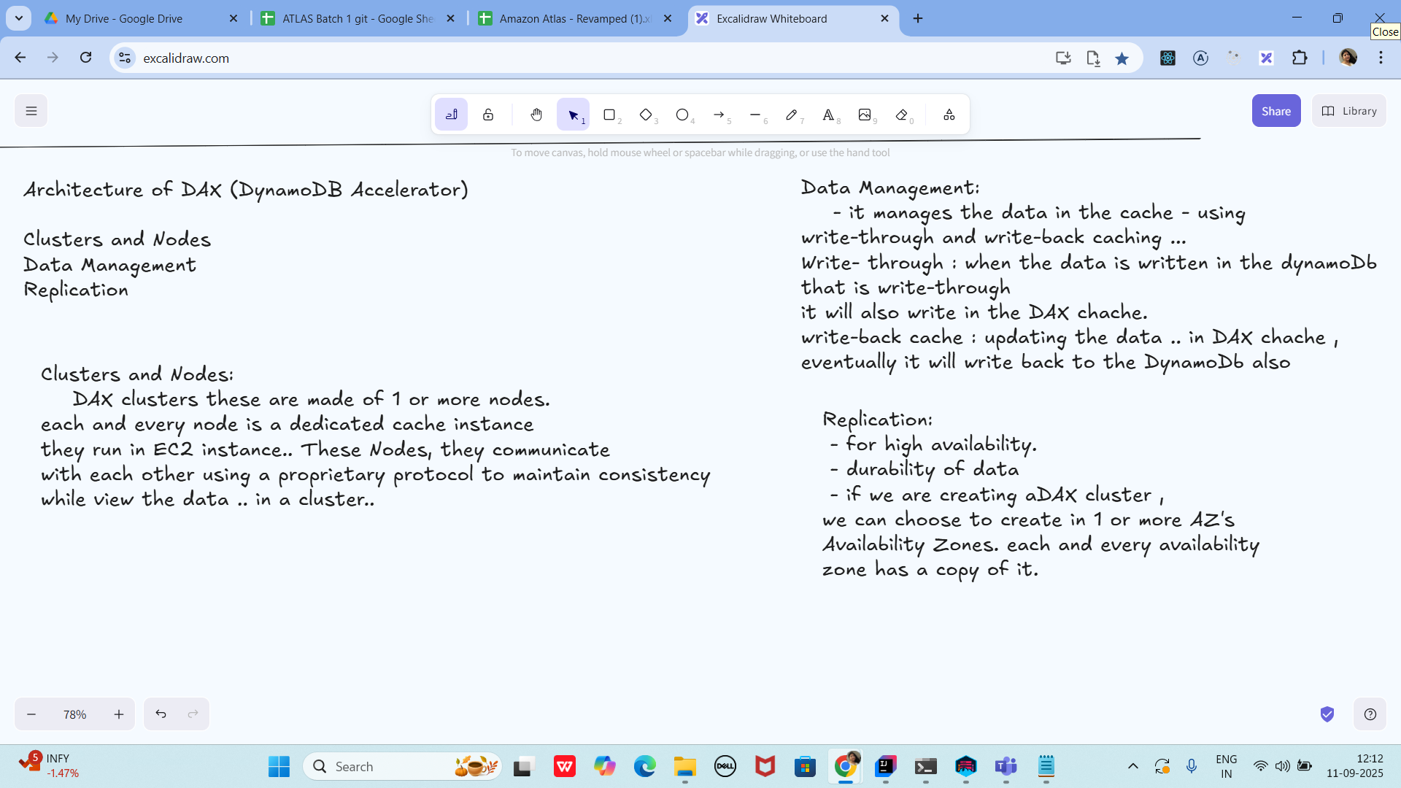

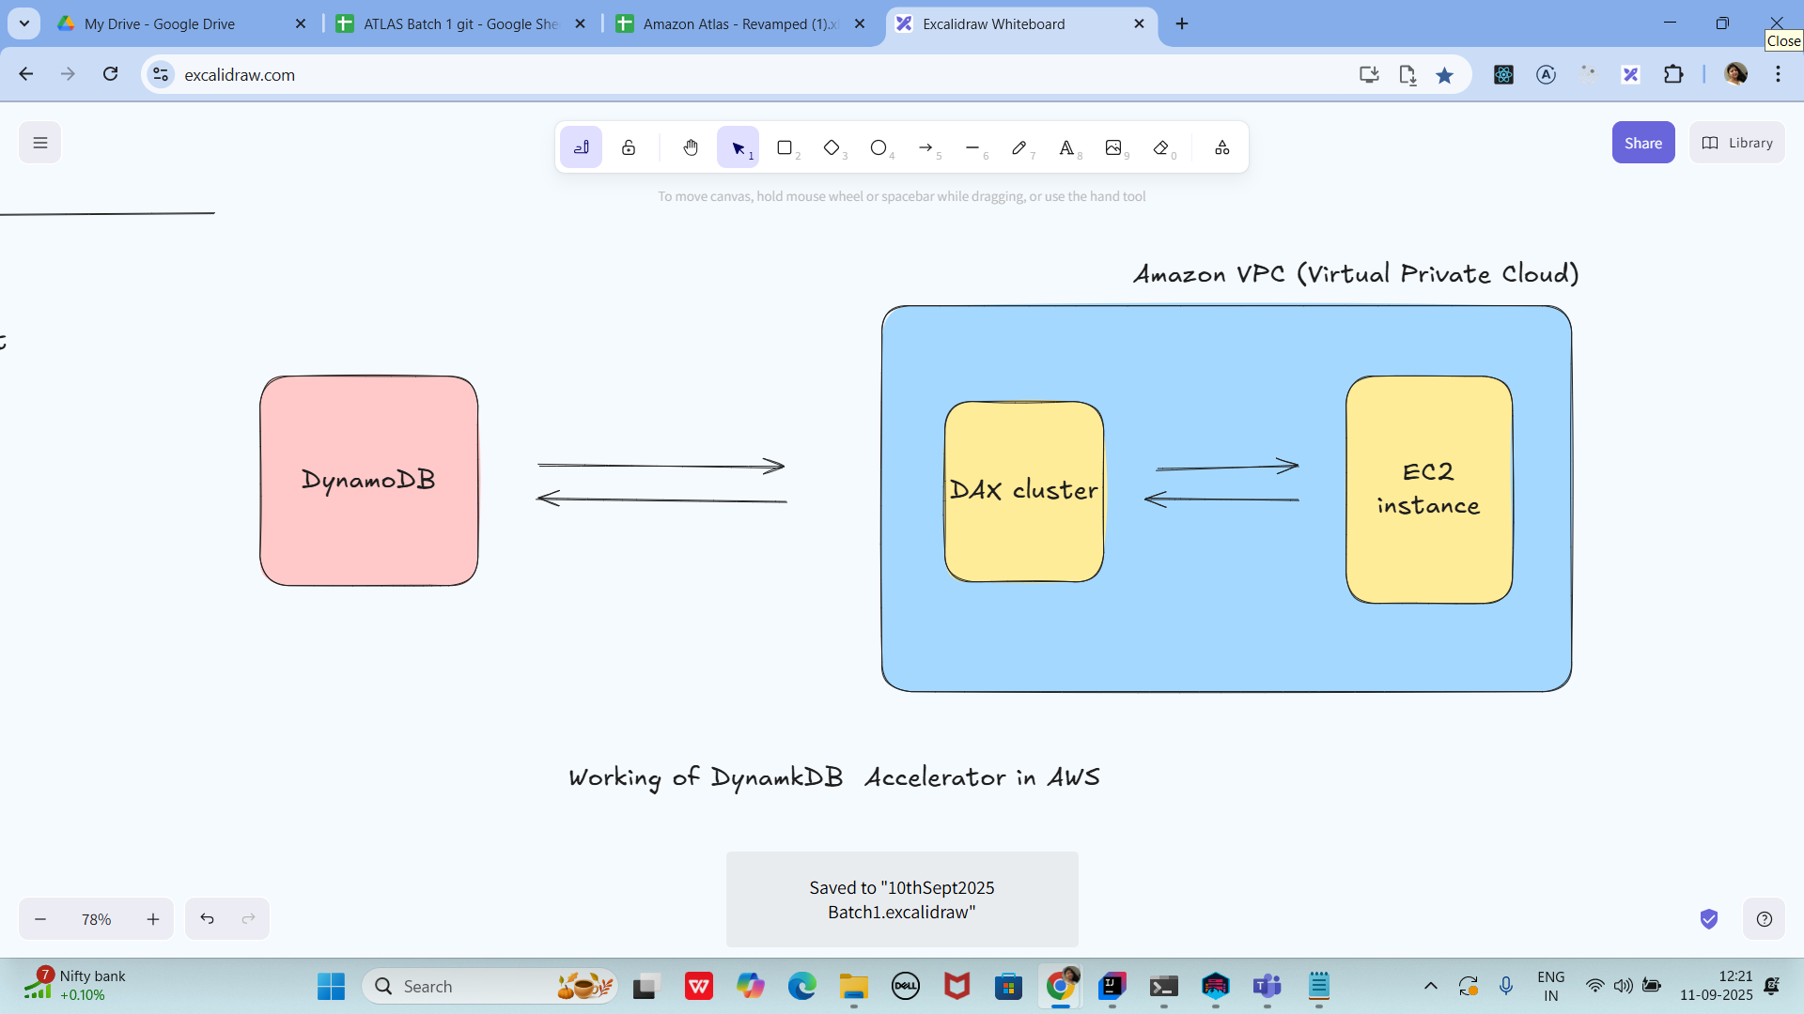

Creating a DAX cluster in AWS (using Console).

Requirements for resting cluster.

→ you need to have an AWs account … with permissions for DynamoDB and DAX.

—> create a table (old table also works

—> you need to create VPC and subnet

—> IAM Role will be used by DAX for Access to DynamoDB

Open DAX console

→ sign in to AWS management console

→ search for DynamoDB —> check for DAX cluster (left plane)

→ create cluster..

Configure Cluster settings:

→ Cluster name : give any name of your choice

→ Node type : dax.r5.large

→ cluster size : number of Nodes (1 to 3 for prod purpose)

→ IAM role:select the IAM role… (it has grants for AmazonDynamoDbFullAccess or create a custom role by giving the dynamoDb permissions..

Network settings:

VPC: plz select VPC the dynamoDB app is in

Subnets: you need to choose at least one subnet

Security groups : add security groups … which will allow the traffic from our app ECS
Or Lambda Functions.

Encryption and Security (this is not compulsory)

Encryption : we need to enable the encryption at rest ( not compulsory)

Parameter group : leave the default values as is..

TTL
Cachesing ….

Create it…. Try to review all the settings that you have given …

In the below screen shot you can see the status of my cluster as available

And also DAx endpoint copy from here and paste it in your code… instead of standard DynamoDB SDk

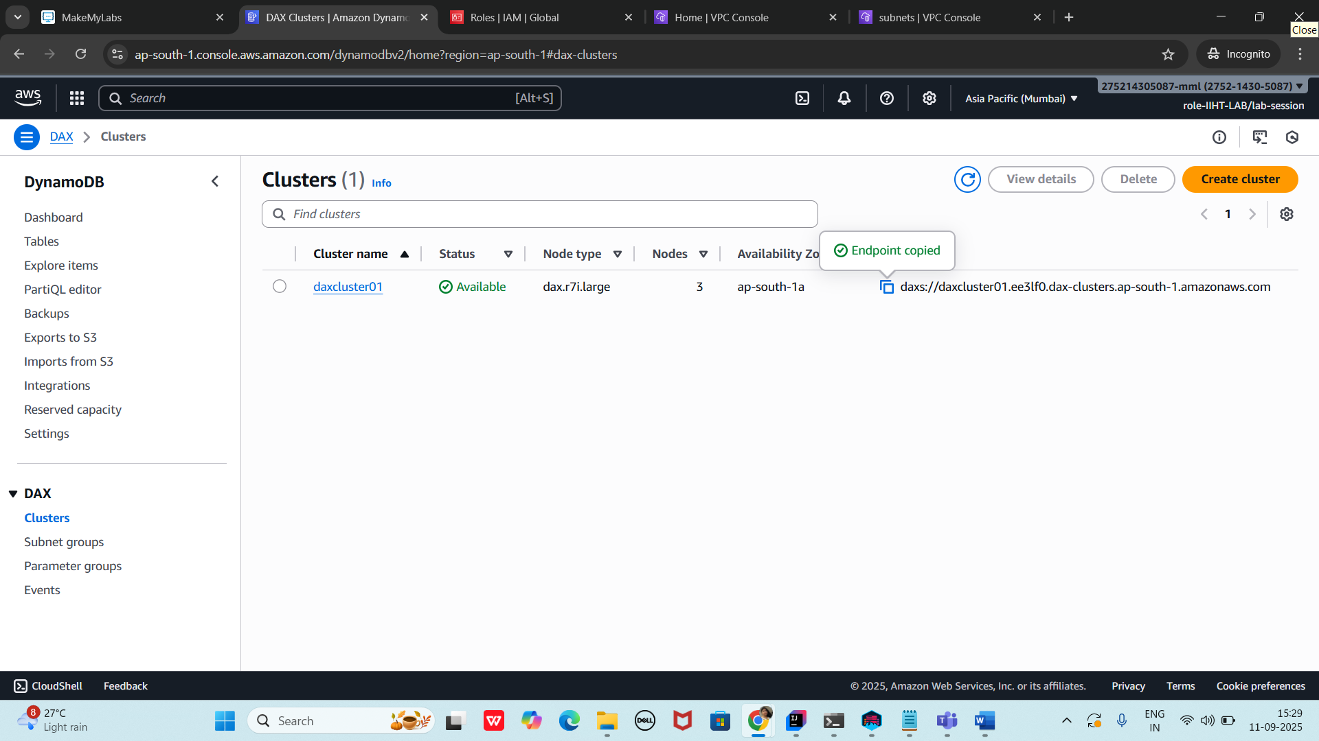

package org.example.Accelerator_DAX;

import software.amazon.awssdk.auth.credentials.DefaultCredentialsProvider;
import software.amazon.awssdk.auth.credentials.DefaultCredentialsProvider;
import software.amazon.awssdk.regions.Region;
import software.amazon.awssdk.services.dax.DaxClient;
import software.amazon.awssdk.services.dynamodb.model.AttributeValue;
import software.amazon.awssdk.services.dynamodb.model.GetItemRequest;
import software.amazon.awssdk.services.dynamodb.model.GetItemResponse;
import software.amazon.awssdk.services.dynamodb.model.PutItemRequest;

import java.net.URI;
import java.util.HashMap;
import java.util.Map;

public class AcceeleratorDAXDemo {
public static void main(String[] args) {
//get this end point created using AWS cloud
// create a acluster..
String daxEndpoint = "daxs://daxcluster01.ee3lf0.dax-clusters.ap-south-1.amazonaws.com";

// we are creating DAx client
DaxClient daxClient = DaxClient.builder()
.endpointOverride(URI.create(daxEndpoint))
.region(Region.AP_SOUTH_1)
.credentialsProvider(DefaultCredentialsProvider.create())
.build();

String tableName = "Employees01";
String KeyName = "ID";
String KeyValue = "10001";

Map<String, AttributeValue> item = new HashMap<>();
item.put(KeyName, AttributeValue.builder().s(KeyValue).build());
item.put("msg", AttributeValue.builder().s("we are creating DAX ").build());

PutItemRequest request = PutItemRequest.builder()
.tableName(tableName)
.item(item)
.build();

daxClient.putItem(request);

Map<String, AttributeValue> getItem = new HashMap<>();
getItem.put(KeyName, AttributeValue.builder().build());

GetItemRequest request = GetItemRequest.builder()
.tableName(tableName)
.key(getItem)
.build();

GetItemResponse response = daxClient.getItem(request);
System.out.println("Dax working ..");
daxClient.close();
}
}

<dependency>
<groupId>software.amazon.awssdk</groupId>
<artifactId>dax</artifactId>
<version>2.20.100</version> <!-- Use the latest stable version of the SDK -->
</dependency>

================================================================================================================================================

Info Box:

Excalidraw updated at 12.12

https://excalidraw.com/#json=rIeLskxVfnDg78qOxC1rl,7hWMM7GtvEsIKJ858Gzk3w

Creating a DAX cluster using the AWS Management Console

https://docs.aws.amazon.com/amazondynamodb/latest/developerguide/DAX.create-cluster.console.html

